As we can see, shared memory significantly improved the running time compared to when we were allocating the matrix in global memory. In addition, the adjustment of the code such that we initialize the boundaries and save them in shared buffers allowed us to have an added value on the running time since we spared the unnecessary constraints when computing the anti-diagonals

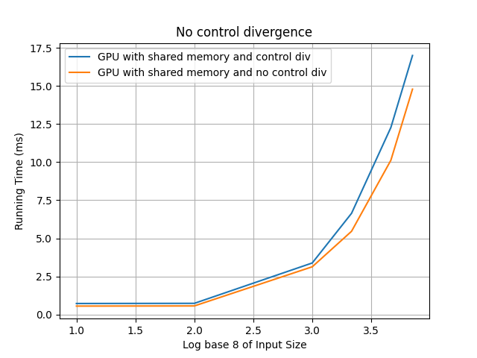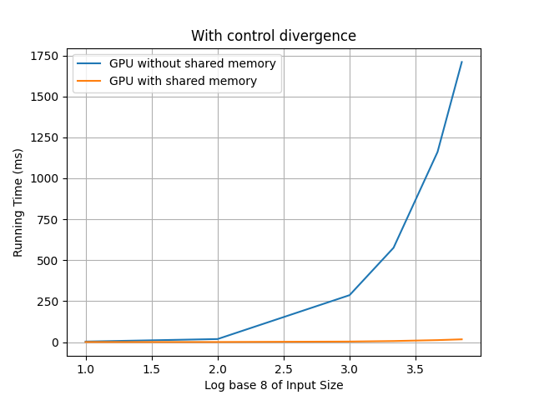Specs: NVIDIA RTX 4060 and INTEL CORE I7 13th GEN